1. 进入/etc/sysconfig/network-scripts/目录下会看到本机的网卡

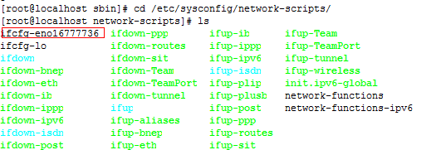

1. 将ifcfg-eno16777736复制一个，



命名为ifcfg-eno16777736:1

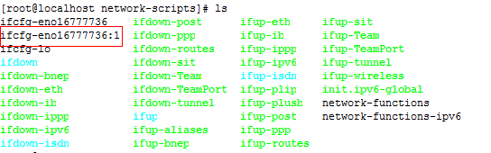

3.打开ifcfg-eno16777736:1

vim ifcfg-eno16777736:1

得到如下：

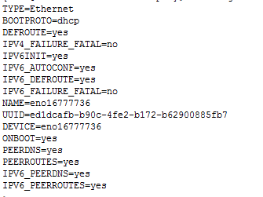

1. 改动文档

DEVICE=ifcfg-eno16777736:1

IPADDR=192.168.228.100（有时可能没有这一句，那么就自己加上）,如下:

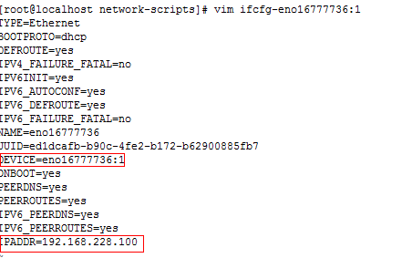

1. 重启系统

reboot

1. 配置nginx



在http中新添加一个service

|  |
| --- |
| user root;  #user nobody;  worker_processes 1;  #error_log logs/error.log;  #error_log logs/error.log notice;  #error_log logs/error.log info;  #pid logs/nginx.pid;  events {  worker_connections 1024;  }  http {  include mime.types;  default_type application/octet-stream;  #log_format main '$remote_addr - $remote_user [$time_local] "$request" '  # '$status $body_bytes_sent "$http_referer" '  # '"$http_user_agent" "$http_x_forwarded_for"';  #access_log logs/access.log main;  sendfile on;  #tcp_nopush on;  #keepalive_timeout 0;  keepalive_timeout 65;  #gzip on;  server {  listen 80;  server_name localhost;  #charset koi8-r;  #access_log logs/host.access.log main;  location / {  root /home/ftpuser/www/;  index index.html index.htm;  }  #error_page 404 /404.html;  # redirect server error pages to the static page /50x.html  #  error_page 500 502 503 504 /50x.html;  location = /50x.html {  root html;  }  # proxy the PHP scripts to Apache listening on 127.0.0.1:80  #  #location ~ \.php$ {  # proxy_pass http://127.0.0.1;  #}  # pass the PHP scripts to FastCGI server listening on 127.0.0.1:9000  #  #location ~ \.php$ {  # root html;  # fastcgi_pass 127.0.0.1:9000;  # fastcgi_index index.php;  # fastcgi_param SCRIPT_FILENAME /scripts$fastcgi_script_name;  # include fastcgi_params;  #}  # deny access to .htaccess files, if Apache's document root  # concurs with nginx's one  #  #location ~ /\.ht {  # deny all;  #}  }  server {  listen 80;  server_name 192.168.228.100;  #charset koi8-r;  #access_log logs/host.access.log main;  location / {  root /home/ftpuser/www/;  index index.html index.htm;  }  }  # another virtual host using mix of IP-, name-, and port-based configuration  #  #server {  # listen 8000;  # listen somename:8080;  # server_name somename alias another.alias;  # location / {  # root html;  # index index.html index.htm;  # }  #}  # HTTPS server  #  #server {  # listen 443 ssl;  # server_name localhost;  # ssl_certificate cert.pem;  # ssl_certificate_key cert.key;  # ssl_session_cache shared:SSL:1m;  # ssl_session_timeout 5m;  # ssl_ciphers HIGH:!aNULL:!MD5;  # ssl_prefer_server_ciphers on;  # location / {  # root html;  # index index.html index.htm;  # }  #}  } |

1. 重启nginx

./nginx -s reload

如果不出错，在浏览器上打入刚加入的ip

http://192.168.228.100/images/330716-15030911415022.jpg

出现图片，说明配置成功